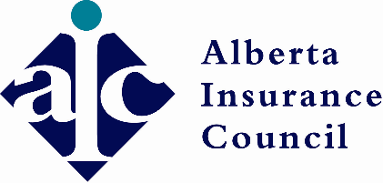

**Call for Nominations for Election to the Life Insurance Council**

The Alberta Insurance Council is seeking nominations to fill the position of  
**1 (one) Life Insurance Agent with the Life Insurance Council.**

**Do you know an eligible colleague?**  
If so, send us your nomination today! To be considered candidates must:

* reside in Alberta;
* be engaged in the insurance business, hold a Life Insurance Certificate of Authority, and have held the certificate for the five years before the election;
* never have been convicted of an offence under the Insurance Act (the Act);
* never have had their Certificate of Authority suspended or revoked;
* never have been levied a penalty under Section 480 (1)(a) of the Act, and not have been levied a penalty in the preceding five years under Section 480 (1) (b, c, d, or e) of the Act;
* not be an employee of an insurer licensed to undertake life insurance;

Full eligibility requirements can be found in **Sections 3 and 29** of the Insurance Councils Regulation by [clicking here](http://www.qp.alberta.ca/1266.cfm?page=2001_126.cfm&leg_type=Regs&isbncln=9780779732388).

No individual may be nominated as a candidate for membership on more than one Council at the same time, nor may they be a candidate for membership or a member on a Council and Appeal Board at the same time.

**What are the expectations of a nominee if elected?**  
A position on the Life Insurance Council holds a term of three years, meeting once each month.

Compensation is paid on a per diem basis. Expenses directly associated with attending to Life Insurance Council business will be reimbursed.

**How do I nominate a candidate?**  
All nominations may be submitted to the Alberta Insurance Council by email to [elections@abcouncil.ab.ca](mailto:elections@abcouncil.ab.ca). Requirements for nomination are as follows:

* A letter of nomination signed by a minimum of five licensed Life Insurance Agents.
* A brief biography for the candidate, including a headshot, that may be distributed to eligible voters.
* **Nominations must be received no later than 4:30 pm on August 22, 2024.**

For further information, please contact Perry Lin at 587-390-0233.